Safer Neighbourhood Team Newsletter:
Droitwich East and West
Issue 6 | April 2023.

Bringing you updates from your local Safer Neighbourhood Team (SNT). The Droitwich team consists of two sides – East and West.
- Droitwich East SNT cover: Droitwich Town; Tibberton; Crowle; Himbleton; Bradley Green; Cookhill; Dodderhill; Inkberrow; The Lenches; Abbots Morton and a number of smaller communities.
Team members: PC Warren Edmunds; PCSO Vicky Elliott; PCSO Dee Bushell; and PCSO Maria Francolini.

- Droitwich West SNT cover: Westlands; Hindlip; Hartlebury; Ombersley; Elmbridge; Hadley; Cutnall Green and a number of smaller communities.
Team members: PC Warren Edmunds; PCSO Andrea Leslie; and PCSO Dee Bushell.

New Addition to the Team – PC Sarah Clarke is the new Safer Neighbourhood Officer for Droitwich East. Sarah was previously a response officer for 3 and a half years. Mainly covering Worcester, but has also spent time covering Droitwich.
Sarah says “I am looking forward to getting involved in the local community and making a difference. I am a very friendly, approachable, sociable person and look forward to attending local community events/meetings”.
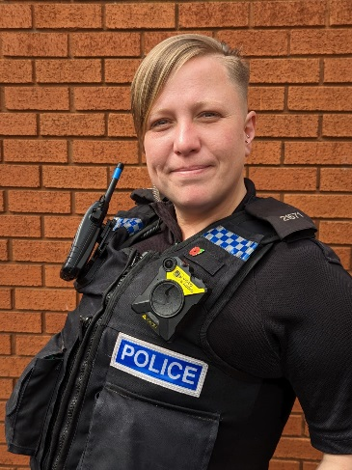

Community Safety Focus
- DANGERS IN DERELICT BUILDINGS – The team have received a number of reports of young people trespassing on the grounds and on the roof and inside buildings.
These buildings and grounds pose a number of dangers – broken glass; unsafe floors; unstable roofs (containing asbestos). Floors could “give way” underfoot or ceilings could collapse. Therefore leading to trespassers suffering serious injury or even death.

Any persons found trespassing at these locations are liable to criminal proceeding being taken against them.

- COMMUNITY SPEED WATCH.
Community Speed Watch is a community driven road safety initiative. It enables community volunteers to address concerns about inappropriate traffic speed on local roads in their area. It is supported by the Police & Crime Commissioner and coordinated by West Mercia Police Road Safety Team. The scheme is managed and run by volunteers in the community and is in place for areas that do not meet criteria for speed enforcement.
The scheme involves police trained volunteers from the community monitoring the speeds of vehicles with speed measurement devices. Where vehicle speeds are found to be inappropriate, letters are sent to the drivers by the police with the aim of encouraging them to reduce their speed when driving in future.
The aim of Community Speed Watch is NOT to catch as many speeding drivers as possible. It aims to encourage motorists to drive at a safe and appropriate speed, reduce speed in areas of concern and address concerns from local residents. The Community Speed Watch scheme enables West Mercia Police to be much more responsive to the needs of local communities.
A number of criteria have to be met in order for a Community Speed Watch site to be approved.

- NEIGHBOURHOOD MATTERS – Is a messaging system which enables residents, businesses and community groups to keep in touch with local policing teams. You can receive updates on crimes, latest information on on-going incidents, crime prevention and fraud alerts and learn more about what we're doing in your community.
To sign up go to: www.neighbourhoodmatter.co.uk

A busy few months for the team …
- Local officers have been continuing to conduct speed enforcement and surveys in and around the Droitwich Policing area.
- The East Team, went to Inkberrow Allotments mark the property of the allotment holders.
- The SNT have been to a number of local schools covering the subject of “People who Help”.

Incidents of note
- There have been three car key burglaries during April in the Primsland area of Droitwich. All three vehicles have been recovered. There have been three arrests made in connection to two of the burglaries and enquiries are on-going.

Keep in contact with your SNT
Email:
droitwicheast.snt@westmercia.police.uk
droitwichwest.snt@westmercia.police.uk
Twitter: @DroitwichCops
Facebook: @DroitwichCops
For crimes in progress call 999.
For non-emergencies report online: www.westmercia.police.uk/report

The team will continue to be available at a variety of drop in events, and surgeries at Droitwich Library.

